Balanced and Unbalanced Forces
When two forces are balanced:
- A stationary object stays stationary.
- A moving object moves at the same speed.
- An object’s shape will stay the same.
When two forces are not balanced:
- A moving object will change speed.
- A stationary object will move.
- An object’s shape will change.

Look at the pictures of the truck below. The arrows represent the forces acting on the truck. A longer arrow shows a larger force and a shorter arrow shows a smaller force.

- The forces on the truck are ________________.
- The truck will _______________________________________________.

- The forces acting on the truck are _______________.
- The larger force is acting in the _______________ direction as the movement of the truck.
- The truck will _____________________________.

- The forces acting on the truck are _______________.
- The larger force is acting in the _______________ direction to the movement of the truck.
- The truck will _____________________________.

- How can you tell if the forces acting on an object are balanced?

- Give two examples of situations where the forces on an object are balanced.

- How can you tell if the forces acting on an object are unbalanced?

- Give two examples of situations where the forces on an object are unbalanced.

- As you sit on your chair, are the forces acting on you balanced or unbalanced? Explain your choice.

- A bike is slowing down to a stop. Explain why the forces acting on it must be unbalanced.

- Look at the picture of the two tug of war teams. Below each child is their strength in newtons.
  - Are the two teams balanced? If not, which team will win?

  - Try to make the teams balanced.

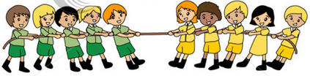

32N 20N 20N 10N 23N 7N 10N 13N 9N 6N

